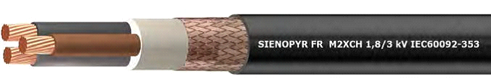

Design features - Conductor Copper, round stranded acc. to IEC 60228 class 2 or class 5

Insulation Cross - linked-polyethylene (XLPE) acc. to IEC 60092-360

Core identification - 1-core: brown, 3-core: brown, black, grey

Inner covering - Halogen free, flame retardant compound

Screen - Plain copper wire braid

Outer sheath - Polyolefine compound, type SHF-1, according to IEC 60092-360